31.38: a) If 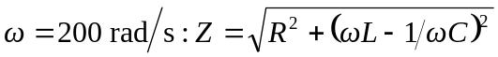
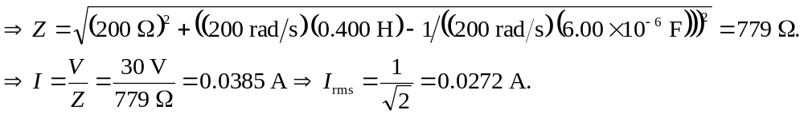
So,
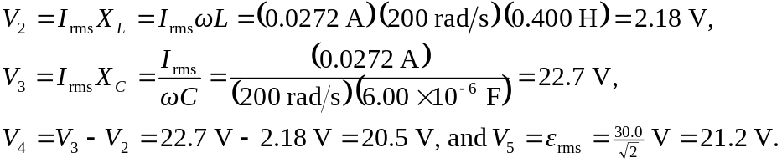
b) If 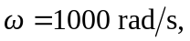 using the same steps as above in part
(a):

